**Results from Data Assimilation (DA) using C balance model with WTC-3 data**

**Carbon Balance Model (CBM) description:**

We plan to use a DA-modelling framework, similar to that used by Richardson et al. (2013) and Mahmud et al. (in review, BGD). This approach uses a simple carbon balance model shown in **Figure 1**. The model is driven by daily inputs of gross primary production (GPP). GPP immediately enters a non-structural C pool (Cn), and total maintenance respiration (Rm,tot) is subtractedfrom the Cn pool. The remainder is then utilized for growth at a rate *k*. Of the utilization flux, a fraction *Y* is used in growth respiration (Rg), and the remaining fraction (1-*Y*) is allocated to structural C pools (Cs): among foliage, wood and root (Cs,f, Cs,w, Cs,r). The foliage and root pools are assumed to turn over with rate *sf* and *sr* respectively. We assume there is no wood turnover as evidenced from the experiment.

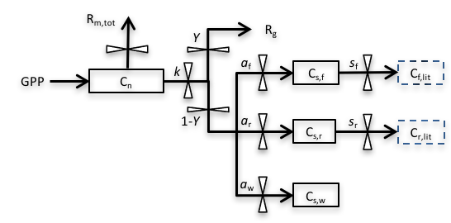

**Figure 1**: Structure of the Carbon Balance Model (CBM). Pools, shown as solid boxes: Cn, non-structural storage C; Cs,f, structural C in foliage; Cs,r, structural C in roots; Cs,w, structural C in wood. Dummy pools, shown as dashed boxes: Cf,lit, total C in foliage litter; Cr,lit, total C in root litter. Fluxes, denoted by arrows, include: GPP, gross primary production; Rm,tot, total maintenance respiration; Rg, growth respiration. Fluxes are governed by seven key parameters: *k*, storage utilization coefficient; *Y*, growth respiration fraction; *af*, allocation to foliage; *aw*, allocation to wood; *ar=(1−af−aw)*, allocation to root; *sf*, foliage turnover rate; *sr*, root turnover rate.

The dynamics of the four carbon pools (Cn, Cs,f, Cs,w, and Cs,r) are described by four difference equations:

Where *k* is the storage utilization coefficient; *Y* is the growth respiration fraction; *af*, *aw*, *ar* are the allocation to foliage, wood and root respectively; *sf* and *sr* are the leaf and root turnover rates respectively;  and  are the dummy foliage and root litter pools respectively.

Total maintenance respiration, Rm,tot was calculated as a temperature-dependent respiration rates for foliage, wood and root (Rm,f, Rm,w and Rm,r respectively), multiplied by plant organ C masses (Ct,f, Ct,w, and Ct,r are the total C in foliage, wood and root respectively). Wood respiration was further partitioned into stem and branches. Similarly, root respiration was partitioned into different root size classes (fine, intermediate, coarse and bole roots). Growth respiration (Rg) at each time step was calculated as a modeled respiration rate (*Y*) multiplied by plant biomass changes at that time step ().

Where Rm,s, Rm,b, Rm,fr, Rm,ir, Rm,cr and Rm,br are the maintenance respiration rates with Ct,s, Ct,b, Ct,fr, Ct,ir, Ct,cr and Ct,br are the total C in stem, branches, fine roots, intermediate roots, coarse roots and bole roots respectively.

The non-structural (storage) C pool (Cn) is assumed to be divided among foliage, wood and root tissues (Cn,f, Cn,w, Cn,r) according to empirically-determined fractions. However, WTC-3 experiment only measured leaf non-structural C (Cn,f), and therefore to estimate the partitioning of the non-structural C among different organs, we use data from WTC-4 experiment on similar-sized seedlings of a related species (Eucalyptus parramattensis). We consider different treatments from the experimental dataset, to find the Cn partitioning to foliage, wood and roots. Total carbon in each tissue (Ct) is then calculated as the sum of non-structural carbon (Cn) and structural carbon (Cs) for that tissue.

We estimate seven parameters (*k*, *Y*, *af*, *aw*, *ar*, *sf*, *sr*) of the CBM for this experiment using DA. GPP and maintenance respiration rates will be used as model inputs in the DA framework, whereas the measurements of total aboveground respiration (Rabove), total C masses (Ct,f, Ct,w, Ct,r), foliage litterfall (Cf,lit) and foliage NSC (Cn,f) will serve to constrain the parameters. Aboveground respiration (Rabove) is estimated by summing both maintenance and growth respiration components of foliage and wood.

**Results from DA:**

With the above-mention DA framework, we try various options for parameter settings and the brief introduction along with the performance of the parameter setup is given in **Table 1**. The lowest BIC values indicate the best performing parameter settings for any particular simulation. Detailed description with the results of each simulation (Case) are provided in later sections.

**Table 1:** Various parameter settings and their performance (BIC) in terms of data fit

|  |  |  |  |
| --- | --- | --- | --- |
| Case # | Parameter settings (Linear variation) | BIC | Findings |
| 1 | All parameters are different for both treatments, and vary linearly with time. The model has a NSC storage pool. | **1373** | Linear variation with time has the best data fit compared to higher degrees (quadratic, cubic). |
| 2 | All parameters are different for both treatments, and vary linearly with time. **The model doesn’t have any NSC storage pool.** | 1507 | The model needs the storage pool for better data fit. |
| 3 | All parameters are same for both treatments (so **no treatment effect**), and vary linearly with time. The model has a NSC storage pool. | 3240 | There is definite effect of warming on C balance. |
| 4 | **NSC utilization and growth respiration are same for both treatments**, but allocations and turnovers are different. Parameters vary linearly with time and the model has a NSC storage pool. | 1420 | Works reasonably well. Variable allocations and turnovers make the tunings to adjust the model for constant NSC utilization and growth respiration, could be the reason of good data fit. |
| 5 | **Allocations are same for both treatments**, but rest of the parameters are different. Parameters vary linearly with time and the model has a NSC storage pool. | 1392 | Same logic as case 4, however the root biomass doesn’t fit at all. |
| 6 | **Turnovers are same for both treatments**, but rest of the parameters are different. Parameters vary linearly with time and the model has a NSC storage pool. | 1416 | Same logic as case 4 |
| 7 | All parameters are different for both treatments, and **vary linearly with mean temperature of previous 7 days**. The model has a NSC storage pool. | 1433 | Linear variation has the best data fit, parameters can be defined as a function of temperature |
| 8 | All parameters are different for both treatments, and **vary linearly with plant size (height)**. The model has a NSC storage pool. | 1514 | Linear variation has the best data fit, parameters are also related with plant height variation |

1. **Case 1:** First, we would like to present the best result we get from the DA with optimized parameter setting. In this case, the model (**Figure 1**) has a NSC storage pool with utilization coefficient (*k*). The parameters (*k*, *Y*, *a*f, *a*w, *a*r, *s*f, *s*r) are different for both treatments (ambient and warmed), and vary linearly with time i.e. each parameter is represented as . We tried constant parameter values, and quadratic and cubic variation over time as well, however linear variation with time is found to yield significantly better model fits. **Figure 2** shows the correspondence between modeled C pools and data and **Figure 3** displays all the parameters for both treatments.

** Now the question is how to interpret the parameters, i.e. set up the hypotheses for the warming experiment.

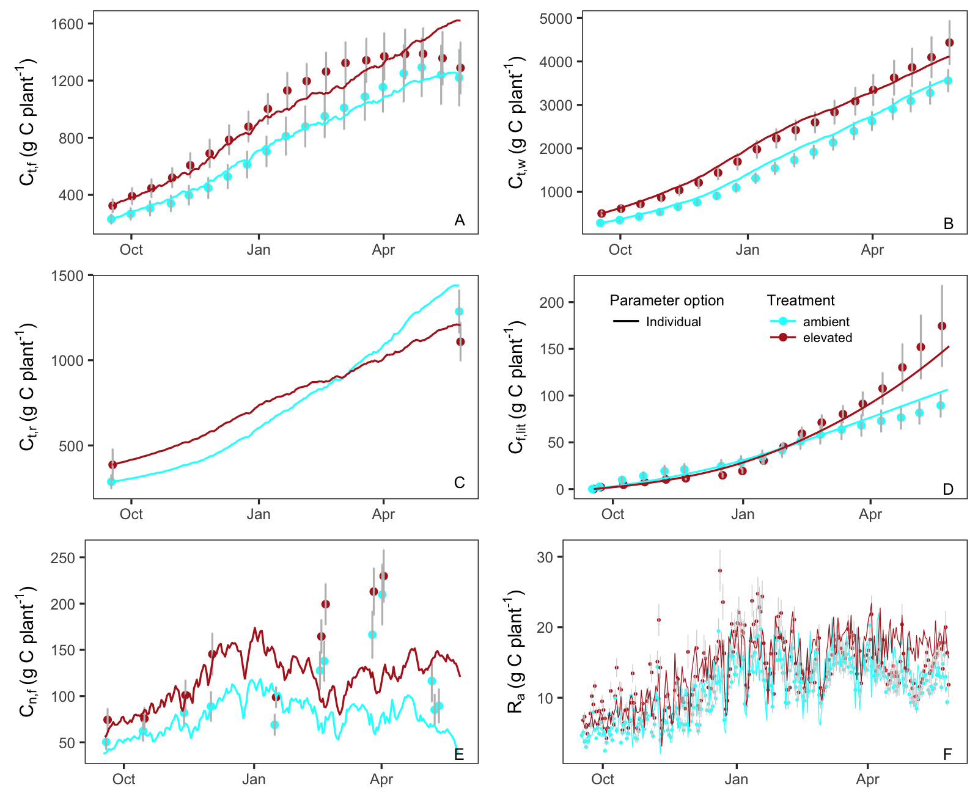

**Figure 2**: Modelled C stocks (lines) with optimum parameter settings and corresponding observations (symbols): (A) total C mass in foliage Ct,f, (B) total C mass in wood Ct,w, (C) total C mass in root Ct,r, (D) total C mass in foliage litter Cf,lit, (E) total C mass in foliage NSC Cn,f and (F) total aboveground respiration Ra. Error bars (1 SE, n = 3, drought treatments are totally excluded) are shown for each observation.

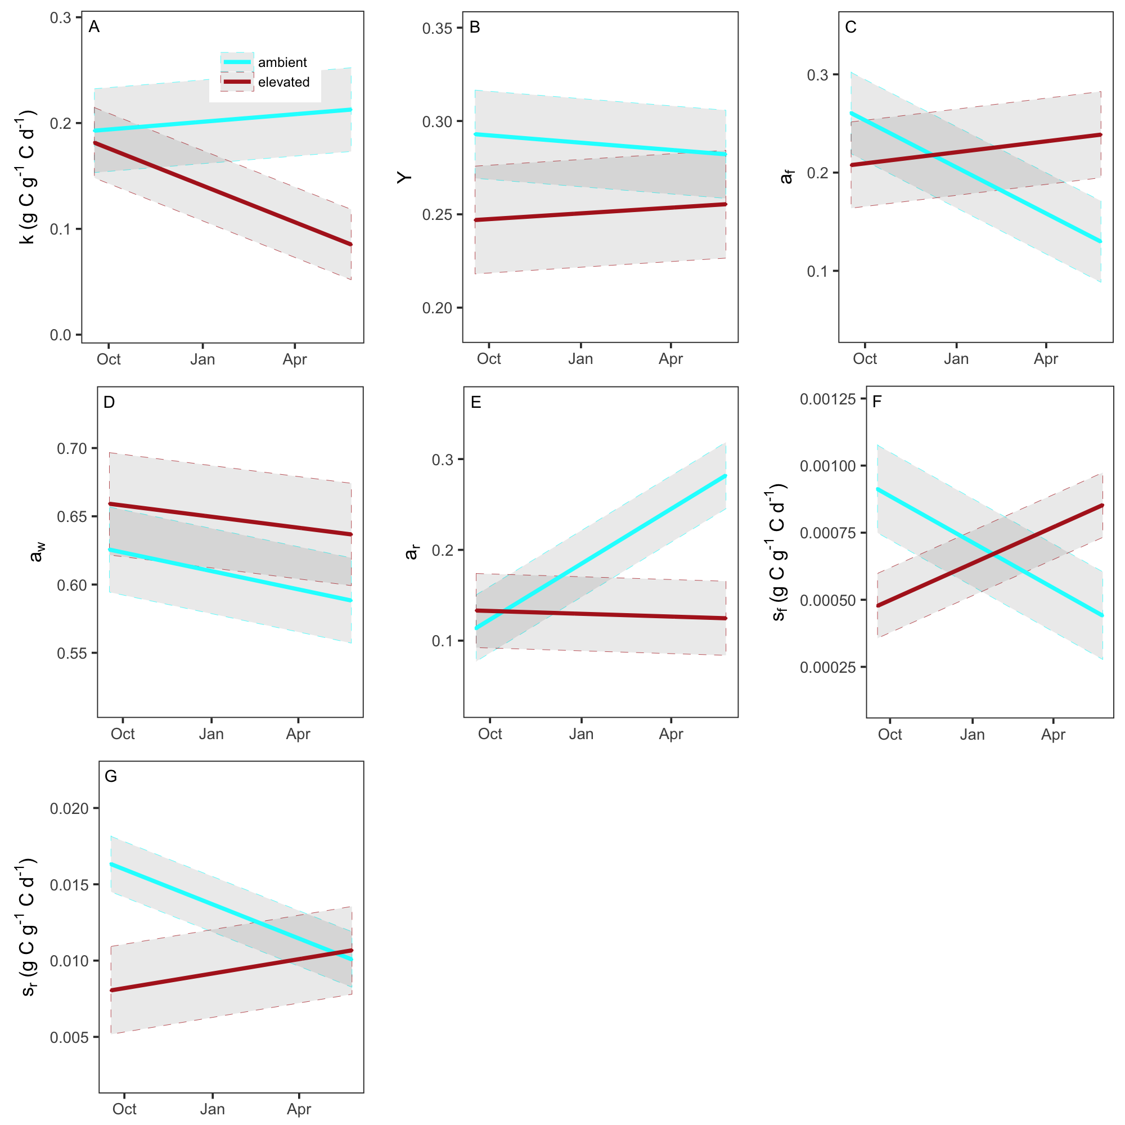

**Figure 3**: Modelled final parameters for both treatments during the experiment period (17th Sept 2013 to 26th May 2014): (A) storage utilization coefficient, *k*; (B) growth respiration fraction, *Y*; (C) allocation to foliage, *af*; (D) allocation to wood, *aw*; (E) allocation to roots, *ar* and (F) foliage turnover rate, *sf* and (G) root turnover rate, *sr*. The grey shaded area shows the 95% confidence intervals of modelled parameters.

1. **Case 2:** Here we consider the simplest model framework assuming all available C from GPP is utilized for growth each day, which means the model does not need a NSC storage pool to fit the data. To test this, we consider the same parameter setup as Case 1, but with the simplified model that omits the non-structural C pool (Cs) from the full model of **Figure 1**. Both the data fit in **Figure 4** compared to **Figure 2** and the BIC (**Table 1**) indicate the need of NSC storage pool in the C balance model.

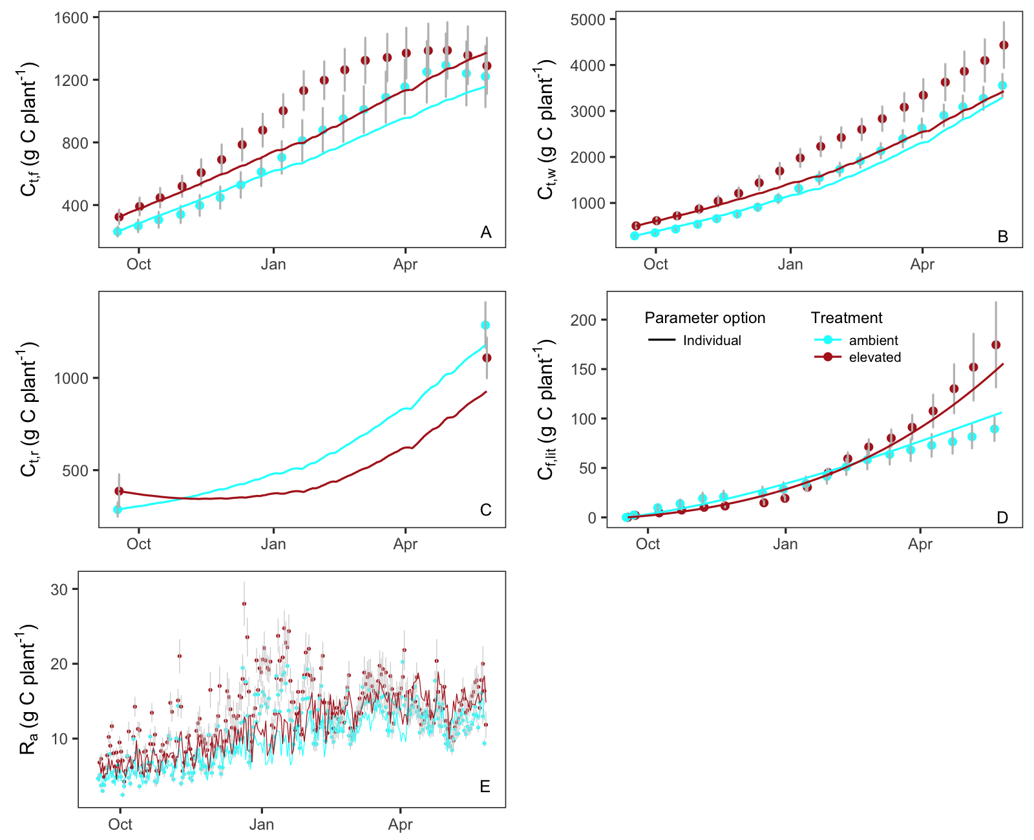

**Figure 4**: Modelled C stocks (lines) with optimum parameter settings but without NSC pool in the model, and corresponding observations (symbols). Note that there is no result for C in foliage NSC, Cn,f.

1. **Case 3:** We then test whether warming has any effect on the C balance, having all parameters same for both treatments. Both the poor data fit (**Figure 5**) and the BIC (**Table 1**) suggest a convincing treatment effect. So, the parameters have to be modelled separately for both treatments.

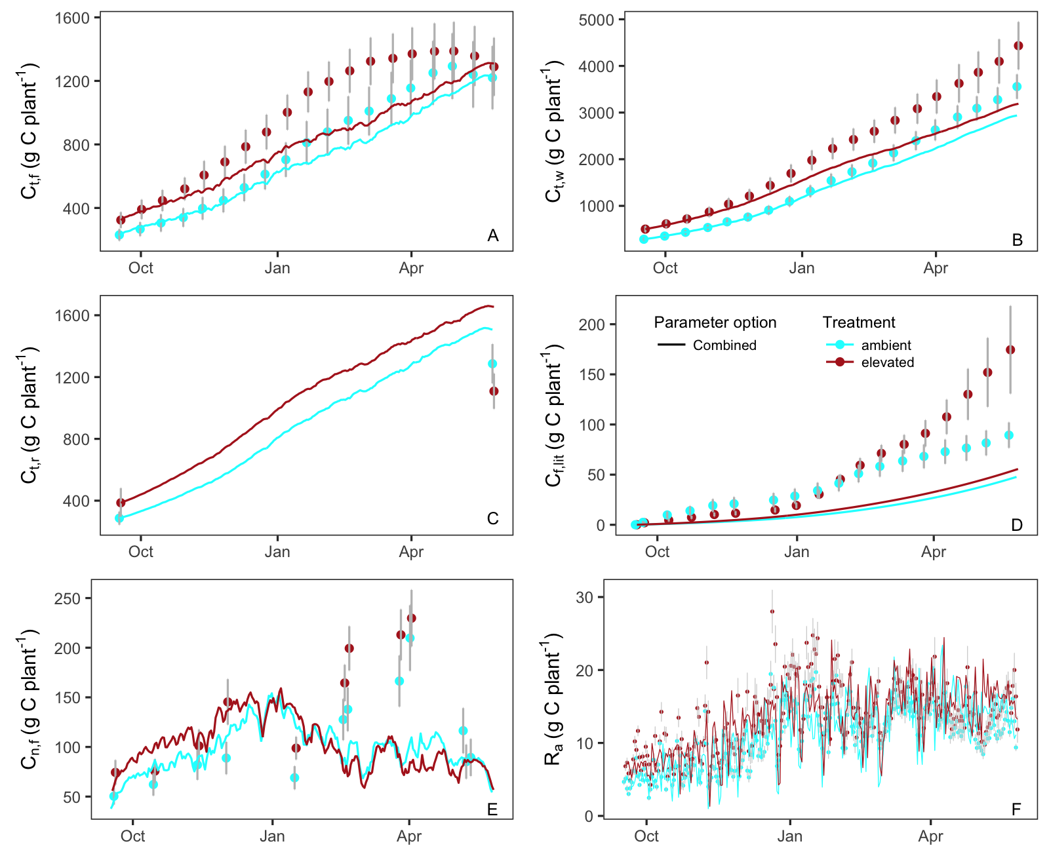

**Figure 5**: Modelled C stocks (lines) with one set of parameters without considering any warming effect, and corresponding observations (symbols).

1. **Case 7:** Now we skip the rest of the cases (Case 4, 5, 6 - having a subset of parameters same for both treatments, i.e. not all the parameters are different) and focus on case 7 that illustrates the parameter setting similar to Case 1, however the parameters vary linearly with mean temperature of previous week. The data fit is reasonably well except the foliage litter, however not equally good as Case 1. Linear variation works equally well as higher degrees (quadratic, cubic) for temperature dependent parameters.

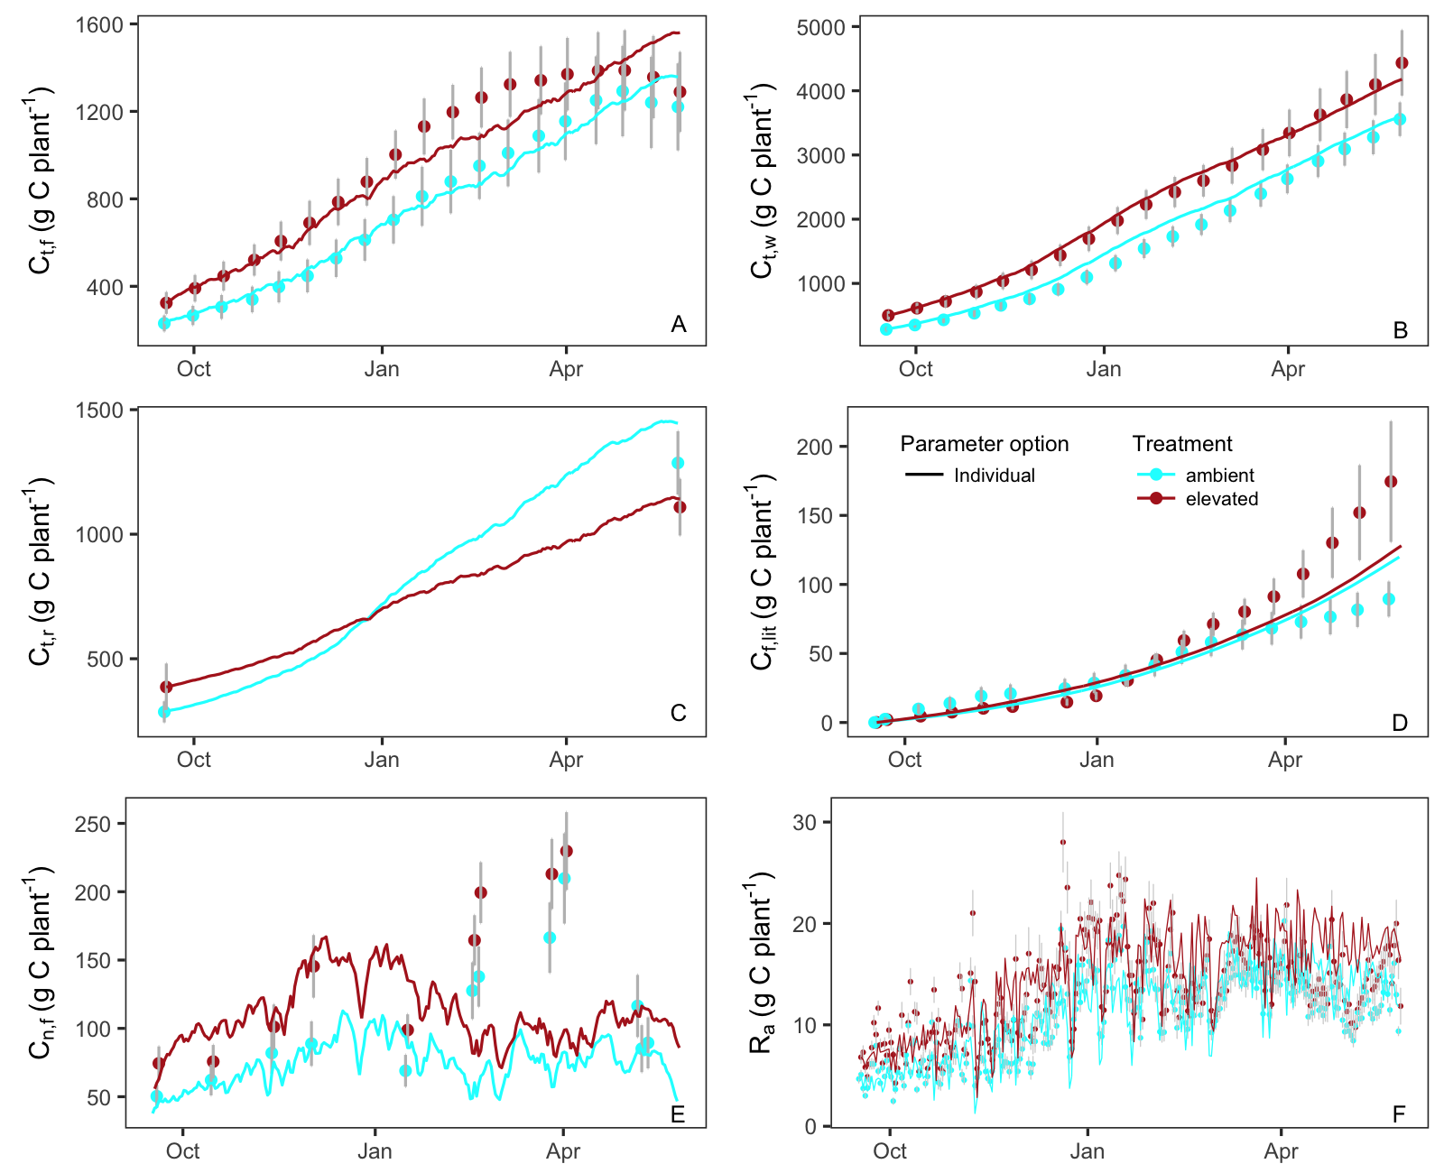

**Figure 6**: Modelled C stocks (lines) with parameter settings varying linearly with mean temperature of previous 7 days, and corresponding observations (symbols).

1. **Case 8:** Finally, we consider the parameters varying linearly with plant size, both plant height and stem diameter are considered. Parameters dependent on height perform better than the diameter-dependent ones, and hence this is shown here. The data fit is not as good as Case 1, but still the parameters can be related with plant height variation. Plant height dependent parameters works only well with linear variation.

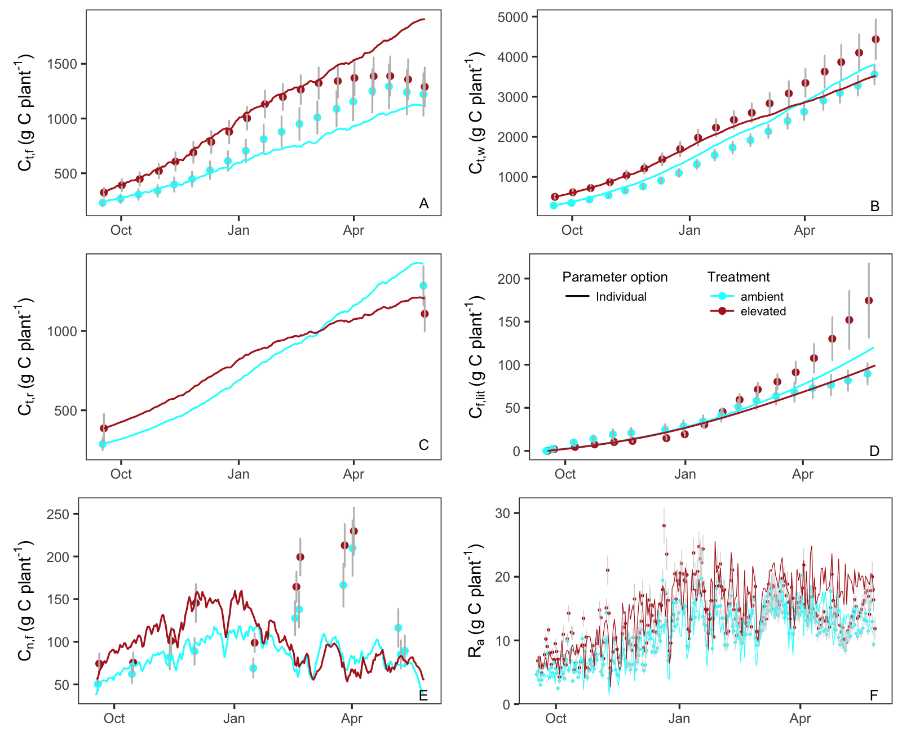

**Figure 7**: Modelled C stocks (lines) with parameter settings varying linearly with plant height, and corresponding observations (symbols).